**Practical 1**

## Print Hello World.

print('hello world')

Output:-



## Practical 2 To display the sum of two numbers

a=int(input('Enter a ')) b=int(input('Enter b ')) print('Sum is ',a+b)

Output:-

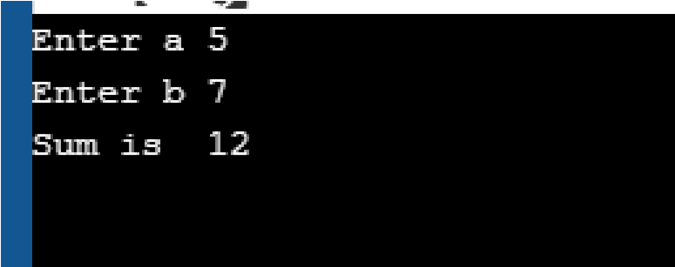

**Practical 3**

## Calculate area of circle.

rad=int(input('Enter radius ')) pi=3.14

print('Area of circle is ',pi*rad**2)

Output:-



**Practical 4**

## Accept a number from keyboard and test whether the given number is even or odd.

a=int(input('Enter a ')) if a%2==0:

print('a is even') else:

print('a is odd')

Output:-

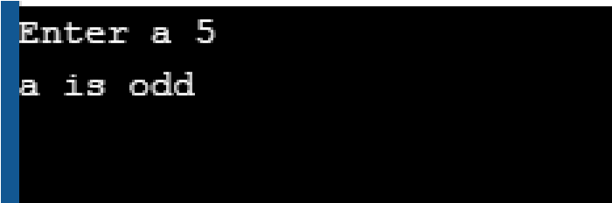

# Practical 5

## To display numbers from 1 to 10 using while loop.

i = 1 while i <= 10: print(i) i += 1

Output:-



# Practical 6

## To display even numbers between X and Y

x,y=map(int,input('enter x & y :').split(' ')) for i in range(x,y): if i%2==0: print(i)

Output:-

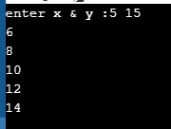

**Practical 7**

## To display the elements of a list using for loop.

mylist=['abc','def','ghi','jkl'] for i in mylist: print(i)

Output:-

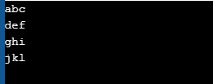

**Practical 8**

## Draw following patterns using nested loops.

**(a)** 

rows = int(input("Enter number of rows ")) for i in range (0, rows): for j in range(0, i + 1): print("*", end=' ') print("")

Output:-

**(**

**b**

**)**

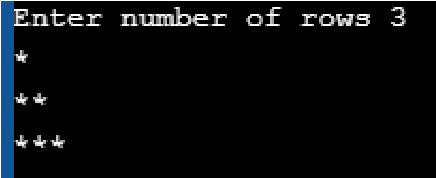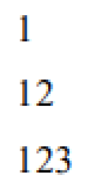

rows = int(input("Enter number of rows ")) for i in range(1,rows+1): for j in range(1, i + 1): print(j,end="") print("")

Output:

-

**(**

**c**

**)**

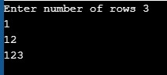

size = int(input("Enter number of size ")) m = (2 * size) - 1 for i in range(0, size): for j in range(0, int(m/2)+1):

print(end=" ") m = m - 2 for j in range(0, i + 1): print("*", end=' ') print(" ")

O

u

tput:

-

**(**

**d**

**)**

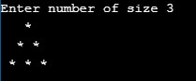

size = int(input("Enter number of size ")) m = (2 * size) - 1 for i in range(1, size+1): for j in range(1, m): print(end=" ") m = m - 2 for j in range(1, i + 1): print(i, end=' ') print(" ")

Output:-

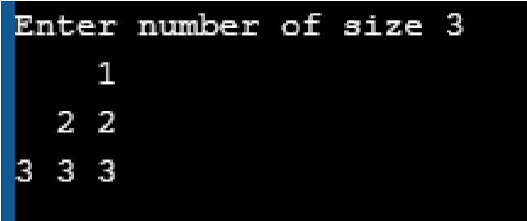

# Practical 9

## Write a Python function to swap two numbers.

def swap_num(a,b): a,b=b,a return a,b

print(swap_num(5,7))

Output:-



# Practical 10

## Write a Python function to find the greatest of 3 numbers.

def gretest_num(a,b,c): if a>b and a>c:

print('a is greater') elif b>a and b>c:

print('b is greater') elif c>b and c>a:

print('c is greater') else: print('Wrong input')

a,b,c = 5,7,9 gretest_num(a,b,c) Output:-

